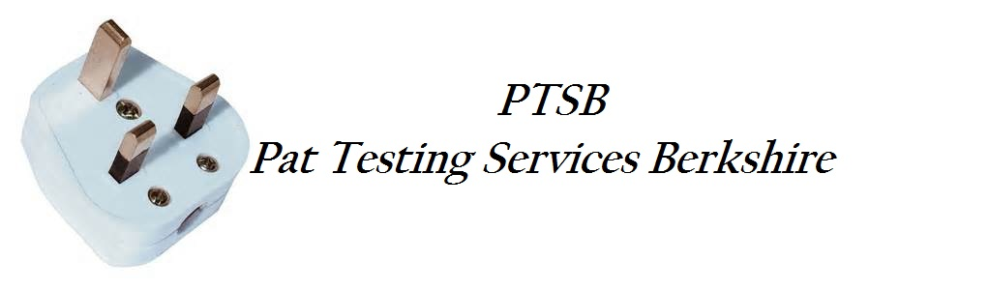

**Concise Test History**

Page 1

24th May 2025

Test Status: All,

Test Type: All Where Available

Person: Doug

Instrument: All

From: 24th May 2025 To: 23rd May 2026

**Client: PINK FROG EVENTS**

**Site: Unit G Swallowfield**

**Location: Brookside Nursery, Swallowfield, Reading** **RG71TH**

**Asset ID Description Result**

6535 EXTENSION LEAD Pass

6536 POP CORN MACHINE Pass

6537 CANDY FLOSS MACHINE Pass

6538 power adaptors Pass

6539 power adaptor Pass

6540 power adaptors Pass

6541 PARCANS Pass

6542 PARCANS Pass

6543 PARCANS Pass

6544 PARCANS Pass

6545 PARCANS Pass

6546 PARCANS Pass

6547 PARCANS Pass

6548 PARCANS Pass

6549 PARCANS Pass

6550 PARCANS Pass

6551 PARCANS Pass

6552 PARCANS Pass

6553 PARCANS Pass

6554 PARCANS Pass

6555 PARCANS Pass

6556 PARCANS Pass

6557 FOUNTAIN Pass

6558 FAN Pass

6559 FAN Pass

6562 FAN Pass

6563 EXTENSION LEAD Pass

6564 EXTENSION LEAD Pass

6565 EXTENSION LEAD Pass

6566 EXTENSION LEAD Pass

6567 power adaptors Pass

6568 power adaptors Pass

656 power adaptors Pass

6570 EXTENSION LEAD Pass

6571 EXTENSION LEAD Pass

6572 EXTENSION LEAD Pass

6573 EXTENSION LEAD Pass

6574 EXTENSION LEAD Pass

6575 power adaptor Pass

LAP00 Laptop 0 Pass

LAP01 Laptop 1 Pass

6576 Projector Small Pass

6577 Projector Large Pass

13905 iec lead (kettle lead) Pass

13906 POPCORN MACHINE Pass

13907 LED LETTER SET A-Z Pass

13908 FAN LEAD ` Pass

13909 FAN LEAD Pass

13910 FAN LEAD Pass

13911 iec lead (kettle lead) Pass

13912 iec lead (kettle lead) Pass

13914 iec lead (kettle lead) Pass

13915 iec lead (kettle lead) Pass

13916 iec lead (kettle lead) Pass

13917 iec lead (kettle lead) Pass

13918 4ft LETTERS (LOVE) Pass

13919 4ft Letters (Mr&Mrs) Pass

13920 Kettle Leads x 2 (speakers) Pass

13921 Candy Floss Machine Pass

13922 Nacho Warmer Pass

13923 Soup Kettle Pass

13924 Soup Kettle Pass

13925 hot dog steamer Pass

13926 Shredder Pass

13926 Arcade Power 1 Pass

13927 Arcade Power 2 Pass

13928 Arcade Power 3 Pass

13929 Arcade Power 4 Pass

13930 Arcade Power 5 Pass

13931 Arcade Power 6 Pass

13932 Air Hockey Table Pass

13933 Festoon Light Power Pass

13934 Fairy Light Light Power Pass